Tax*Breeze*

**Business Requirement Document**

|  |  |
| --- | --- |
| Company | PricewaterhouseCoopers Private Limited |
| Prepared By |  |
| Version | V 1.0 |
| Date | 20/02/2018 |
|  |  |

**Table of Contents**

1. Business Objectives ……………………………………………………………………….. 3

2. Background ………………………………………………………………………………….. 3

3. Scope …………………………………………………………………………………………… 3

4. Features ………………………………………………………………………………………. 3

5. Functional requirements ……………………………………………………………….. 4

6. Tax Return Creation ……………………………………………………………………… 9

7. Admin Functions …………………………………………………………………………… 9

8. Reporting and quality assurance ……………………………………………………. 10

9. Other requirements ………………………………………………………………………. 11

* **Business Objectives**

A web/mobile platform to prepare / e-file tax return with minimal efforts and bare minimum cost with the help of best Tax Experts available in the industry.

* **Background**
  + 1. Most of the Taxpayers are using Tax agents who doesn’t have the mobile/web app that are integrated with regulators. Due to which users are compromising on security, this also results in substantial investment of taxpayer’s time, effort and money for related straight forward returns. This experience results in delay in filling or non-filling of the tax returns.
    2. Some taxpayer’s are having few challenges as none of the mobile/web app available in the current market which is cater with complex taxpayer’s situation and ease the process of the tax return filling. These tax payers either end up delay/non filling or scrutiny or tax assessments by regulators.
    3. Few compliances required under the regulatory framework are provided below
       - Claiming Foreign Tax credit.
       - Understanding treaty.
       - Applying treaty provision.
       - Claim exclusions.
       - Certain unique issues.
* **Scope**

The system should be able to handle both ITR1 and ITR 2 returns as per Income Tax Authority of India. Also, the system should have a set of administrator kind of functionality that will control the functions and content of the web/app. The users should be able to register, submit personal and tax related information, track the status etc. by using the system.

TaxBreeze will aim to provide interactive compliance management system that will automate compliance responsibility of the taxpayer. TaxBreeze is in line with government process of improvising the infrastructure for providing fully online module for electronic return filing with online payment.

* **Features**

This is for preparing and filing income tax returns for Residents of India. The user should be able to register, submit personal and financial details along with supporting documents. It also provides the user the facility to provide online payment for the fee for preparing the tax with the help of PwC tax experts.

* **Functional Requirements**  
   The Website/App will have below sections for users.
* Home
* Registration
* Help Center
* Login
* Dashboard
* Personal Information
* Address Details
* Salary / Other Income Details
* House Property/Rental Details
* Capital Gain
* Deductions
* Assets & Liabilities
* Upload
* Salary/Form 16
* Other Income (Rent receipts, Insurance receipts etc.)
* Housing loan Interest
* Form 26AS
* Foreign Assets
* Bank Details
* Online Payment & Confirmation
* Admin Functions

Please [Click here](Tax%20App.html) to view sample screens for the above listed features.

* **Screen Layout**

Please refer the website of [Airtax](https://airtax.com.au) for the layout and how the functionalities to be presented to the user. The Menu and functionalities to be presented to the user will be explained below in detail. The theme and color combination of the site will be as per PwC branding standards only.

* **Top Menu**
* Services
* Pricing
* Help Center
* Contact
* Login (If user is not logged in)
* User Full Name (if the user is logged in)
* Dashboard
* Logout
* **Bottom Menu**
* Terms & Conditions
* Legal
* Privacy
* Site Provider
* Linking Policy

The content of the links of Top Menu needs to be designed in such a way that the content will be database driven. This will help us to easily change any content for these links in future if required.

* **Sign Up**

The signup screen will look like the one given below. Please note that this is a sample one and as mentioned earlier, the theme and color combination will be different.

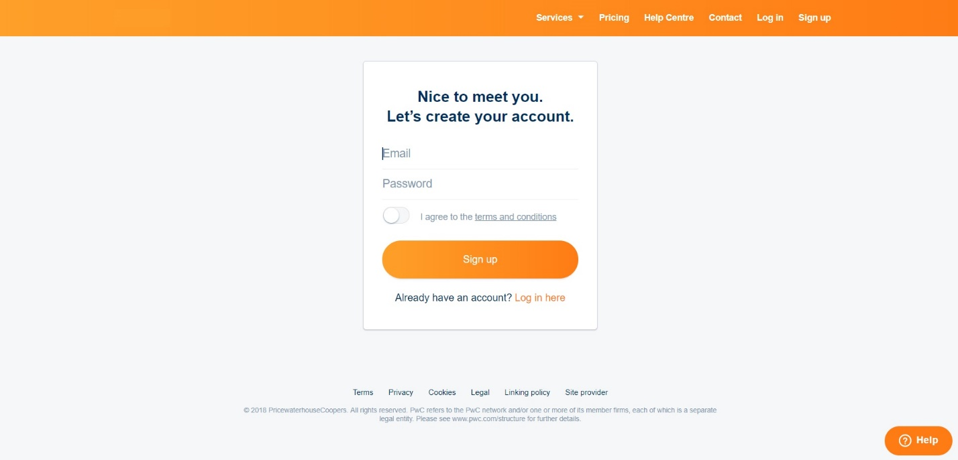

There will be an intermediate screen between landing page and signup screen, and that is given below.

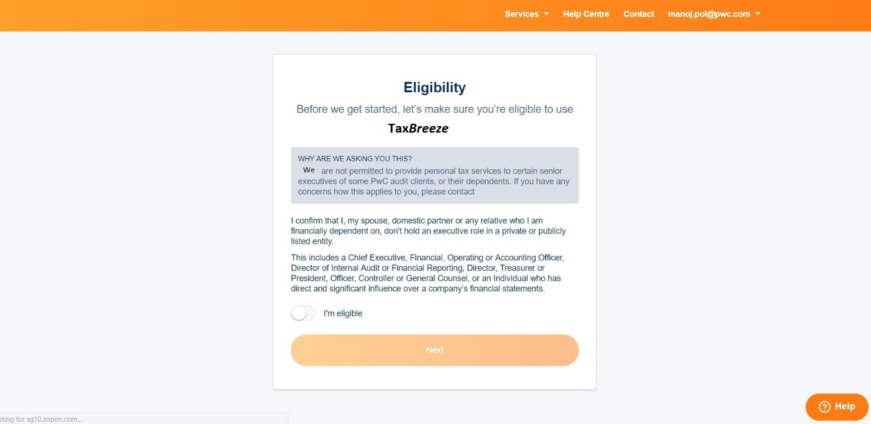

After this screen, store some basic details of the user as given in the below snap.

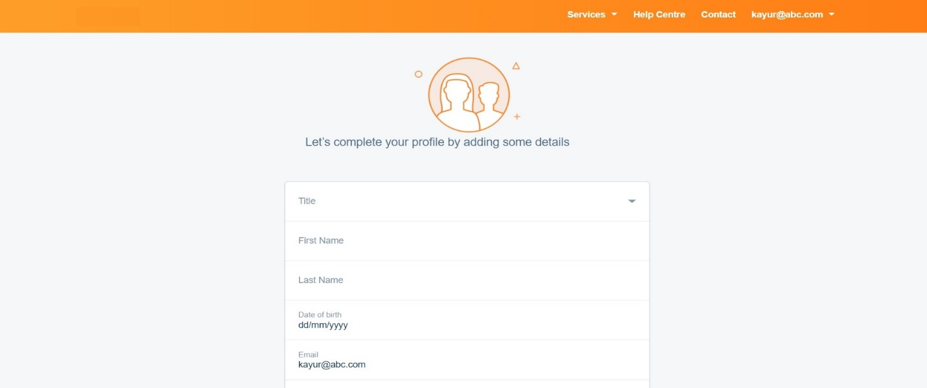

Select the required service available.

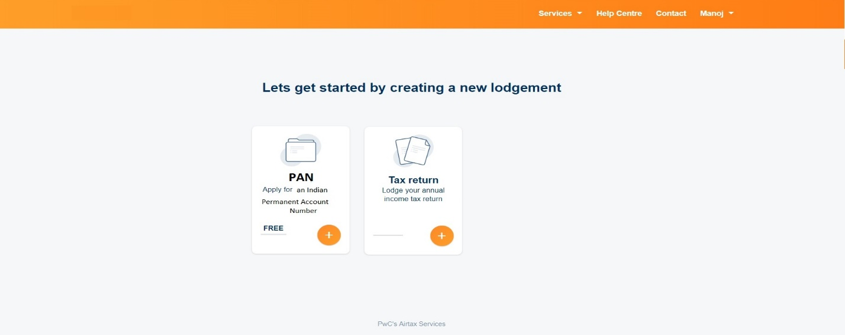

Select the Tax Period for creating the Tax Return

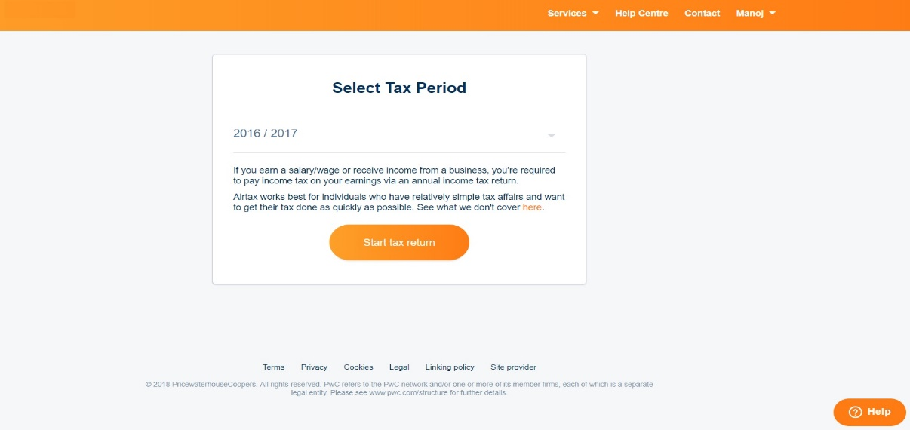

User also has the feature of pre-filling the basic details for Tax preparation using any of the below features as depicted in the snap below.

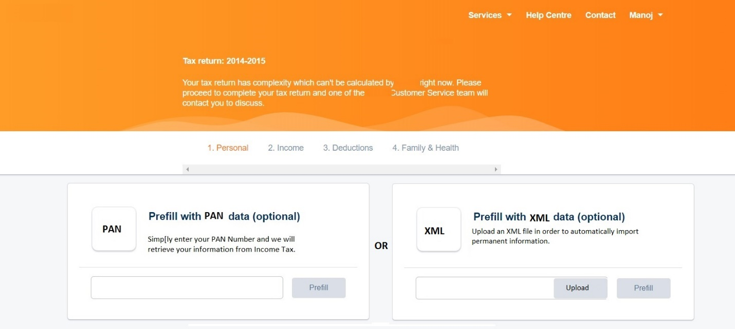

* **Dashboard**

The dashboard for the user will look like the one mentioned below. If the user had created Tax returns for multiple tax years, then all those records should be listed in the dashboard, with proper status of those returns.

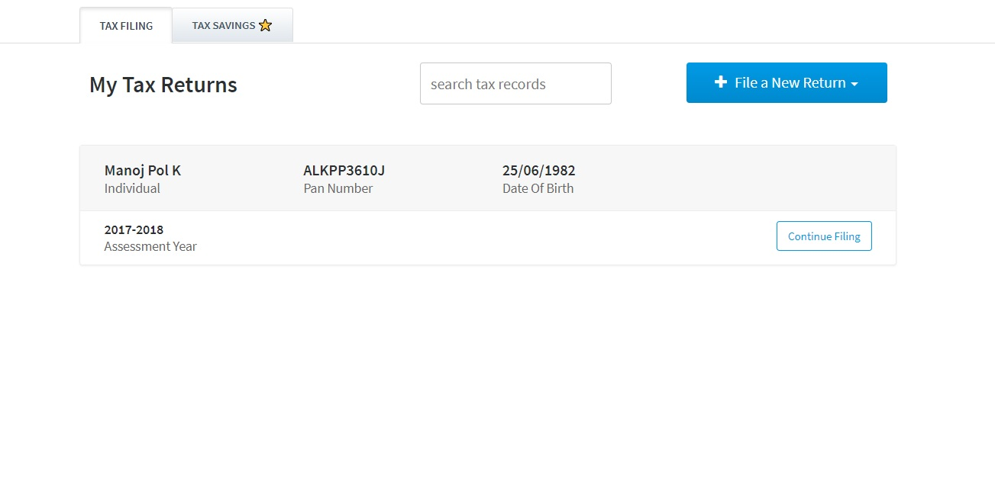

* Document Library:

A Document Library needs to be provided in the dashboard, from where the user would be able to view the uploaded docs (list of docs uploaded for creating tax return pertaining to each Tax Year) and the final docs (the one prepared by the PwC pertaining to each Tax Year). The screen should list all those documents and the user should be able to View/Download them.

* **Tax Return Creation**

The return creation involves a bunch of steps. These are depicted in the html file provided along with this BRD. [Click here](Tax%20App.html) to view the screens.

The Tax Year for this return will be decided when the user clicks on “File a new return”. A Payment Gateway also needs to be integrated in the process on the basis of which the preparation of the return will be decided. It means that unless and until the payment is not done by the user, the return will not be considered for preparation by the PwC tax experts. Different sections for filling the details for Tax Return creation is given below.

1. Basic Information (Tax Questionnaire)
2. Personal Information
3. Address
4. Income Sources

* Salary
* Other Income
* House Property Details
* Rental Property Details
* Capital Gain

1. Deductions

* Section 80 Deductions
* More Deductions

1. Taxes Paid
2. Bank Details
3. Assets & Liabilities
4. Submit
5. Payment (Third party integration required)

* **Admin Functions**

Apart from the functions mentioned above, the system also require certain admin functions to manage the site and features. These functions will be managed by the internal team of PwC, who manages the TaxBreeze functions. Some of such functions are listed below.

* User Management
* Pricing & Offers
  + Plan & Pricing
  + Refer-a-Friend
  + Promotions
* Services
* Contact Details
* Reports
  + User-wise Report
    - Payment Details
    - Return Details
    - Status Details
* Summary Details
  + Tax Year-wise
  + Status-wise
  + Tracking & monitoring tools
* **Reporting & Quality Assurance**

The progress will be monitored on regular intervals. This is to ensure that the product is being developed as per the requirements and if there needs to be any changes then those items can be addressed and implemented accordingly. Demo of the project on regular intervals will be required to check the quality of the product being developed.

* **Other Requirements**

As per PwC standards, the details for color combinations and fonts will be provided in a separate document. These instructions need to be followed while designing the screens both in Web and Mobile App. These parameters will be checked and addressed (if required) while analyzing the quality of the product.